**AB Testing**

A/B Testing means analyzing two marketing strategies to choose the best marketing strategy that **can convert more traffic into sales** (or more traffic into your desired goal) effectively and efficiently.

In A/B testing, we analyze the results of two marketing strategies to **choose the best one** for **future marketing campaigns.**

For the task of A/B testing using Python, we need to have a dataset about two different marketing strategies **for the same goal.**

Here we have 2 groups of datasets [ Control Campaign & Test Campaign]

1. Campaign Name: The name of the campaign
2. Date: Date of the record
3. Spend: Amount spent on the campaign in dollars
4. of Impressions: Number of impressions the ad crossed through the campaign
5. Reach: The number of unique impressions received in the ad
6. of Website Clicks: Number of website clicks received through the ads
7. of Searches: Number of users who performed searches on the website
8. of View Content: Number of users who viewed content and products on the website
9. of Add to Cart: Number of users who added products to the cart
10. of Purchase: Number of purchases
11. We analyze the relationship between the number of impressions we got from both campaigns and the amount spent on both campaigns:

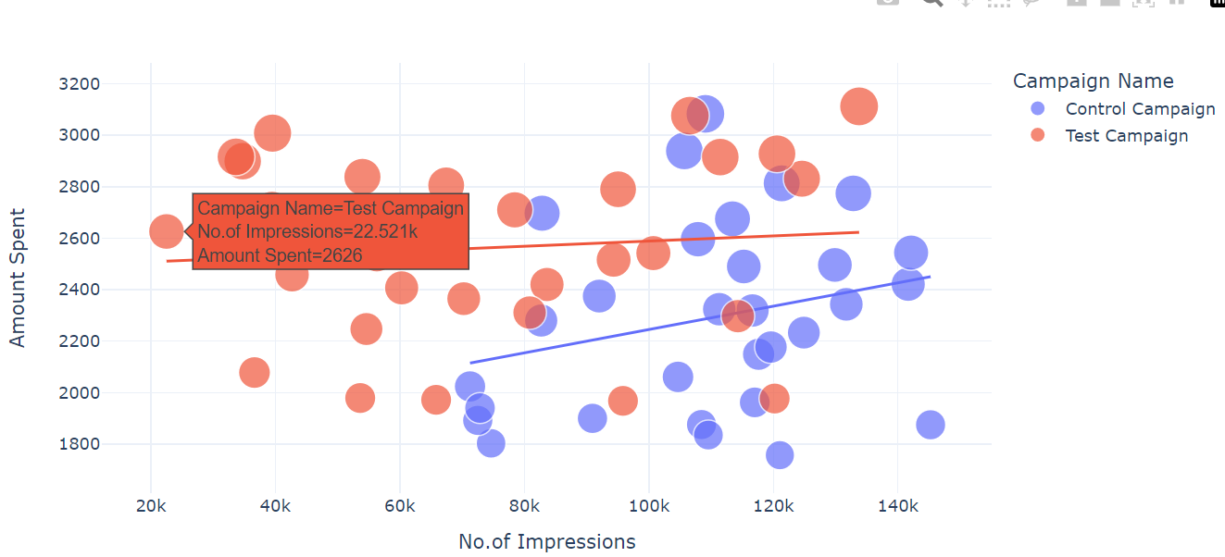

**The control campaign resulted in more impressions according to the amount spent on both campaigns. ### Control Campaign**

1. Number of searches performed on the website from both campaigns:

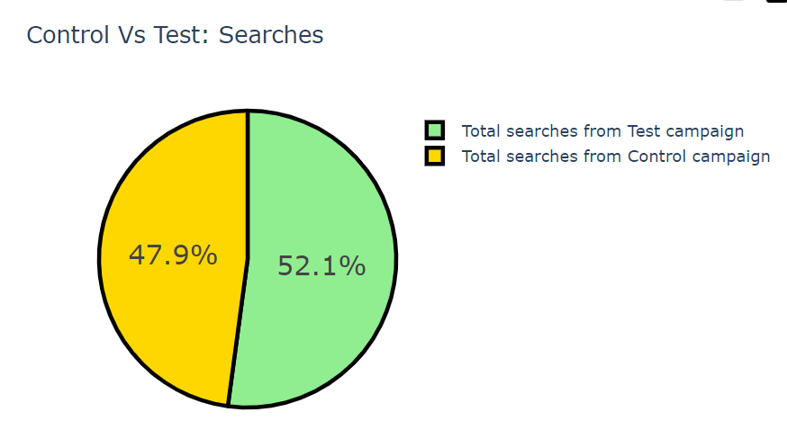

**The test campaign resulted in more searches on the website. ### Test Campaign**

1. Number of website clicks from both campaigns:

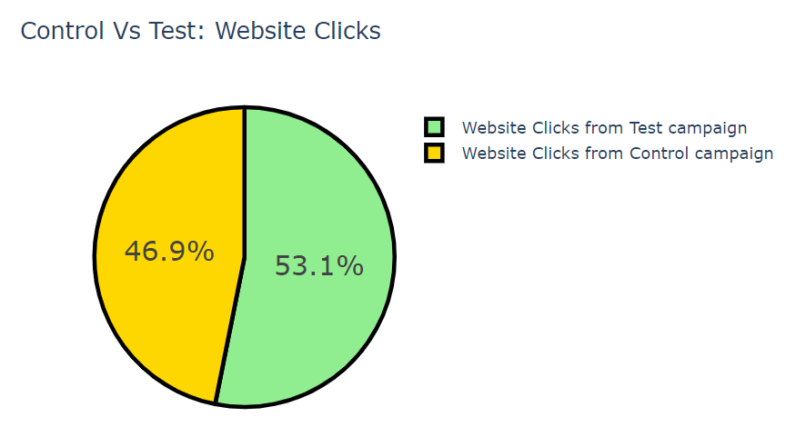

**Test Campaigns has higher No.of Website Clicks as compared to Control campaigns ### Test Campaign**

1. Amount of Content Viewed from Both Campaigns:

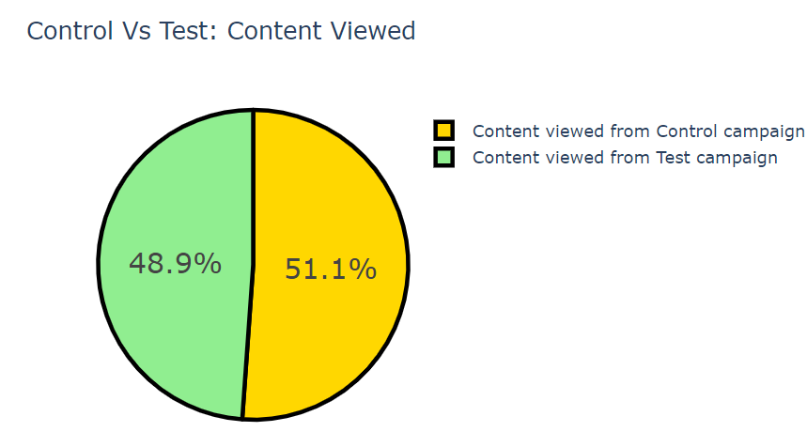

**The audience of the control campaign viewed more content than the test campaign. ### Control campaign**

* **Although there is not much difference, as the website clicks of the control campaign were low, its engagement (Content Viewed) on the website is higher than the test campaign.**

1. Products added to Cart from both campaign:

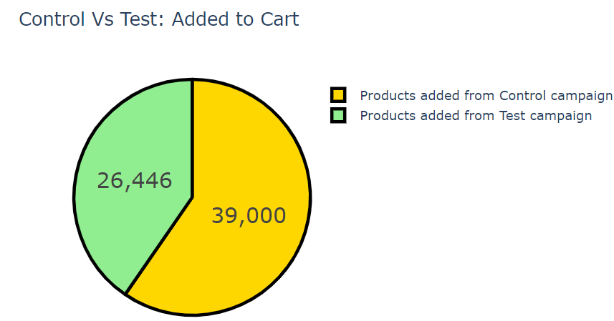

**Despite low website clicks more products were added to the cart from the control campaign. ### Control Campaign**

1. Amount spent on both campaign:

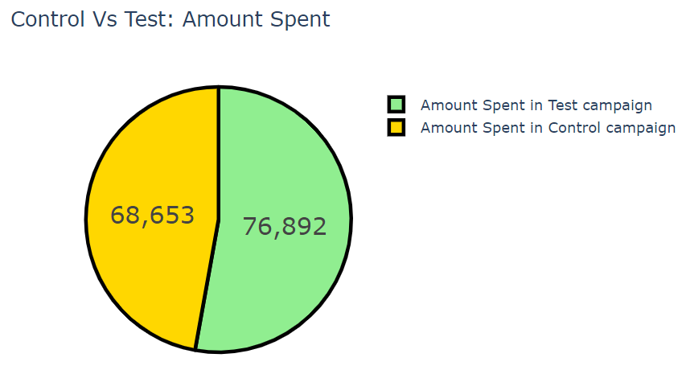

**The amount spent on the test campaign is higher than the control campaign.**

* **But as we can see that the control campaign resulted in more content views and more products in the cart, the control campaign is more efficient than the test campaign.**

1. Purchases Made by both campaign:

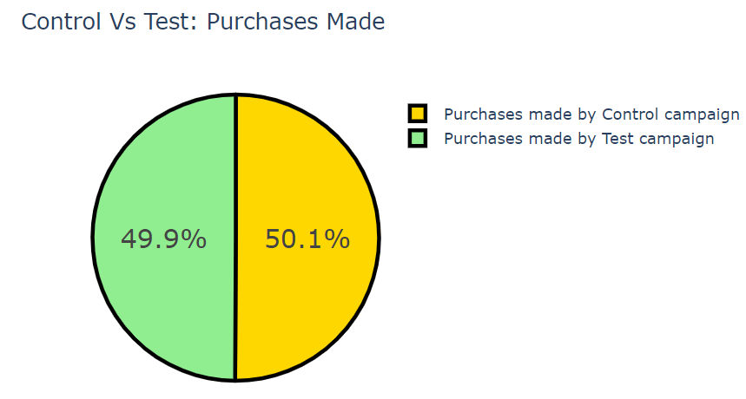

**There’s only a difference of around 1% in the purchases made from both ad campaigns.**

**As the Control campaign resulted in more sales in less amount spent on marketing, the control campaign wins here.**

1. ## Now let’s analyze some metrics to find which ad campaign converts more. ##

I will first look at the relationship between the Number of website clicks and Content viewed from both campaigns: 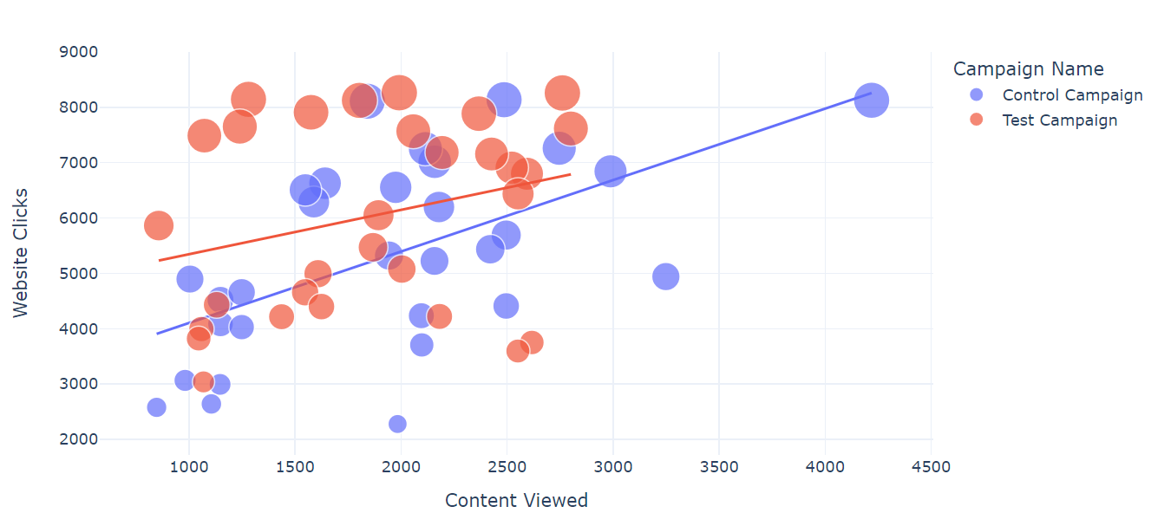

**The website clicks are higher in the test campaign, but the engagement(content viewed) from website clicks is higher in the control campaign. So the control campaign wins here.**

1. Analyzing the relationship between the Amount of content viewed and the Number of products added to the cart from both campaigns:

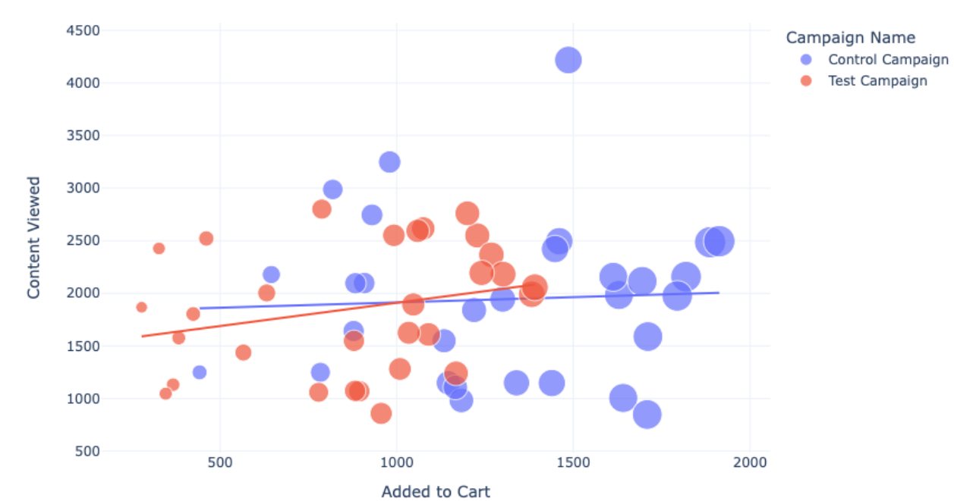

**Here Control campaigns has more No.of products added in the Cart.**

1. Number of products added to the cart and the Number of sales from both campaigns:

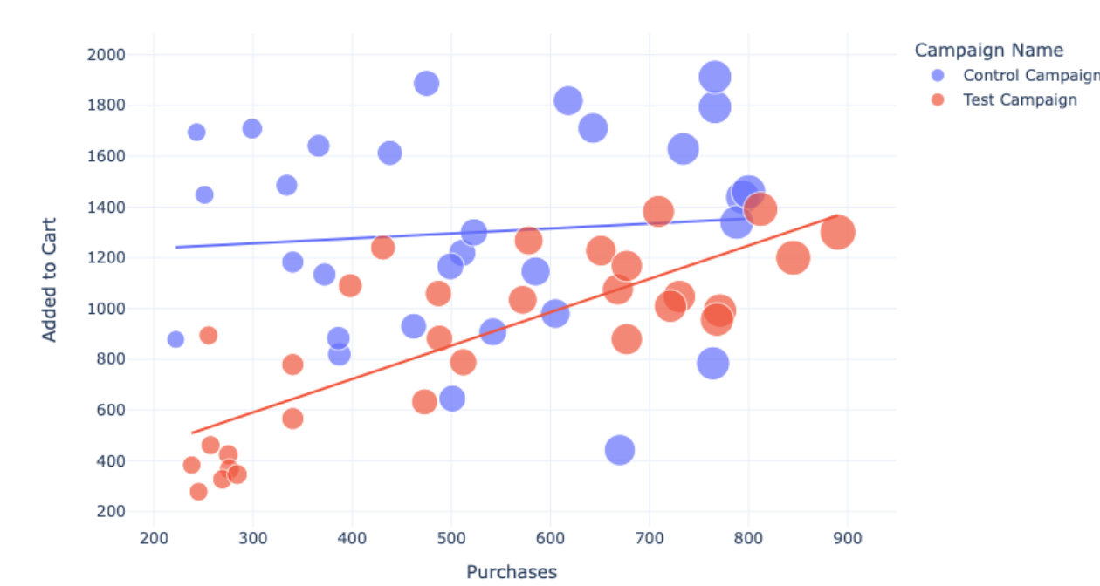

* Although the control campaign resulted in more sales and more products in the cart
* **The conversation rate** of the **test campaign is higher.**

**CONCLUSIONS:**

* **From the above A/B tests, we found that the control campaign resulted in more sales and engagement from the visitors. More products were viewed from the control campaign, resulting in more products in the cart and more sales.**
* **But the conversation rate of products in the cart is higher in the test campaign. i.e No.of Purchases Made.**
* **The control campaign results in more sales overall.**
* **So, the Test campaign can be used to market a specific product to a specific audience, and the Control campaign can be used to market multiple products to a wider audience.**

**##############################*********#################################**